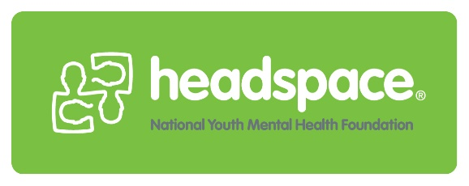
Feedback Form
At headspace we welcome and appreciate your feedback so that we can continually improve our service for young people. You can tell us anything you wish to and it will not affect your access to the service in anyway.

Compliment Complaint Suggestion

Date: / /
Please tell us about your experience at headspace
…………………………………………………………………………………………………………………………………………………………………………………………………………………………………………………………………………………………………………………………………………………………………………………………………………………………………………………………………………………………………………………………………………………………………………………………………………………………………………………………………………………………………………………………………………………………………………………………………………………………………………………………………………………………………………………………………………………………………………………………………………………………………………
Are you (please tick one):
Client: Family/ Carer: Friend:
Would you recommend headspace to your friends? Yes No
Will you return to see us if you need to in the future? Yes No
Would you like us to follow you up on your feedback? Yes No
If yes, please provide your contact information below

Name: ………………………………………... Date of Birth: / /
Phone Number:

Please note that if you wish to, you can give your feedback anonymously. Please either drop this form into the box at reception.
Thank you from the headspace team!

