Frequently Asked Questions

- What is the headspace Berri hERO Group?
The headspace Berri hERO Group is made up of young people who are passionate about youth health.

The headspace Berri hERO Group hopes to:
  - Provide young people with the opportunity to become involved with youth health services in your local community
  - Provide young people with the opportunity to have input into the local headspace services
  - Allow a way for the voice of young people to be heard and acted upon
  - Provide opportunities for young people to development new skills and foster leadership, media, communication and advocacy skills
  - Support young people to lead projects locally.

- What is involved for members?
As members of the headspace Berri hERO Group young people have the opportunity to be involved in a number of ways including:
  - Community engagement, awareness and promotion (including school presentations, community events)
  - Projects and events in-centre and in the wider Riverland community
  - Receive training and development to undertake the hERO role

- What is the time commitment?
  - The initial commitment is for a period of 12 months with the opportunity to extend this out with another application for the subsequent hERO year. hERO members who are 26 years of age at the time of re-application, can apply to become a hERO mentor for the following year.
  - Meetings take place fortnightly and can vary between 1-2 hours.
  - Members must undertake the Youth Advocates Program training provided on commencement in the role.

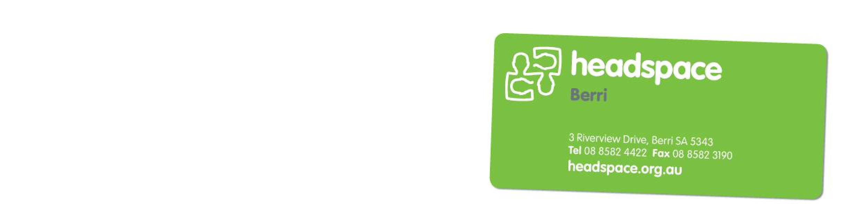
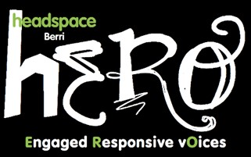
headspace Berri recognises that young people have many conflicting demands on their time, so it is not expected that members attend every meeting, or volunteer for every event outside of regular meetings.

In between meetings and events, contact is maintained through a closed, member only Facebook group, and by phone and email. There will be an expectation that members participate regularly in these discussions.

This is an unpaid volunteer role which provides an array of personal, professional and social opportunities including knowledge and skills training, development and networking.

- Can you tell me more about the activities that I can be involved in?
Young people are supported to become active community advocates for the health and wellbeing of young people. The goal is to raise awareness of youth wellbeing and promote the headspace service as a place for young people to seek help. Young people may also have the opportunity to be involved in community education activities.

Members of the headspace Berri hERO Group will have the opportunity to actively contribute to specific projects within their local community and headspace Berri centre. These projects may include, production of videos, a youth week event, an art competition, a band comp....the possibilities are endless.

hERO members are consulted around specific aspects of our delivery of services to young people, and as such help make decisions about resourcing and planning. The purpose is to ensure that the interests and opinions of young people are represented in all four components of headspace Berri’s work: mental health, physical/sexual health, alcohol and other drug misuse, and vocational/educational support. hERO group members will have the opportunity to attend and participate in the strategic planning day for headspace Berri, usually held in May.

- What are the requirements?
To be between the ages of 16 to 25 and keen to actively participate. No specific previous experience required.

For more information on the headspace Berri hERO Group call 8582 4422, email info@focusonehealth.com.au or visit www.headspace.org.au/berri.

ABN 59 993 489 649 headspace National Youth Mental Health Foundation Ltd is funded by the Australian Government Department of Health and Ageing under the Youth Mental Health Initiative Program.

