Your Personal Information is important.
This is how we try to protect your privacy:
- Your worker at headspace Bairnsdale will talk to you about confidentiality and what that means about the information you share with us.

- We will ask for your name, where you live, and a contact number to make appointments or give you medical results.

- We will write some notes and keep a record of the reasons you have come here. These notes will be stored and locked away so no one else (outside the team) is able to view them.

- If you would like a copy of your notes, you can ask for them at any time. There may be times when we may not let you see your notes, but we will let you know why.

- If you need to see more than one worker such as the Doctor and a Youth Access Worker, some information might be shared between workers so you do not have to tell both people the same things again and again.

- To make sure we are doing a good job, the team talks about the work they do together. Your information will be shared at care planning meetings. These headspace workers will be at these meetings:
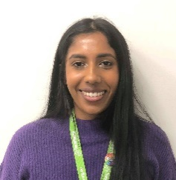
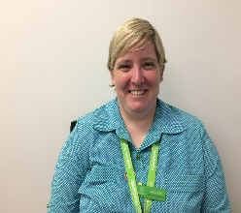
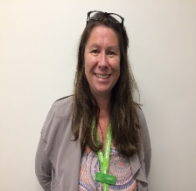
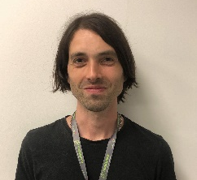
Faith
Renae
Jacinta
Hayley
Jake
Clinical Lead
Youth Access Workers

Information will be kept confidential outside of care plan meetings. All the direct service workers (pictured above) may see your files.

Other workers from other agencies (such as: Child and Youth Mental Health) may attend these meetings too, but we need to get your OK before we talk about our work with you them. Please talk to the intake worker if you have questions about this.
Sharing Your Private Information
There may be times where you say we can share some of your information with other organisations.
We will ask you before we speak to these organisations:

- A specialist doctor or another health practitioner or social
worker outside headspace
- Other organisations that can help you out, for example Centrelink, Youth Justice or your school
- Organisations you have seen in the past.
Sometimes We Can’t Keep Your Information Private
We don't share your information with anyone outside the headspace Bairnsdale team without your permission except:
- If you or someone else is in serious danger of, for example, violence, suicide or self-harm, or another medical emergency such as a reportable disease.

- We might need to tell the police about a serious crime you or someone else did.

- If you are reported to the police as a missing person, we will tell the police that you are ok, but we will not tell the police or your family where you are if you don’t want us to.

- If you are under 16 years old and depending on how mature we think you are.

(Unless we think it is in your best interest, parents/ guardians can usually be given information about what type of service you are accessing – not the content of the session).

- If you are under 18 and tell us that you have been hurt physically or sexually by someone, or you tell us about someone who is under 18 who has been hurt in these ways.

- If a court asks to see the notes we have kept.

In all cases your worker will try to speak with you first before speaking to another service.

Please tick the boxes below:

☐ My worker has explained this information.

☐ I understand this information.

Name: _________________________________________________________________________________________

Signature: _______________________________________________________________________
I am under 16 years old: ☐ Yes ☐ No

(If under 16) Parent/Guardian signature: _______________________________________________

